
Week 2 - Classification of a living organism

One of the first decisions most scientists have to make when classifying something for the first time is if it is alive. What does it mean to be alive? What is the difference between us and the chairs we sit on? Both plants and animals and considered to be alive. What do we have in common that makes us alive?
It has taken many years of observation and discussion for scientists to develop eight characteristics that all living things have plants, animals and even microorganisms and bacteria have in common. To remember all eight characteristics, just remember MR N GREWW

M – Living things can MOVE by themselves
R – Living things can REPRODUCE
N – Living things need NUTRITION
G – Living things GROW as they get older
R – Living things RESPOND to change
E – Living things EXCHANGE GASES with their environment
W – Living things produce WASTES
W – Living things require WATER

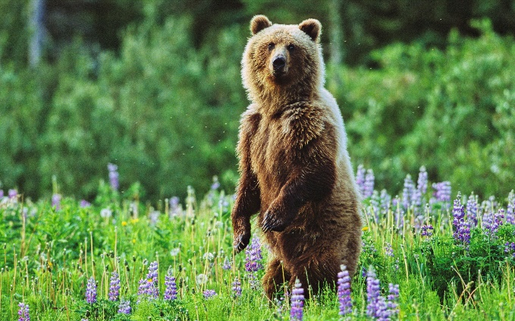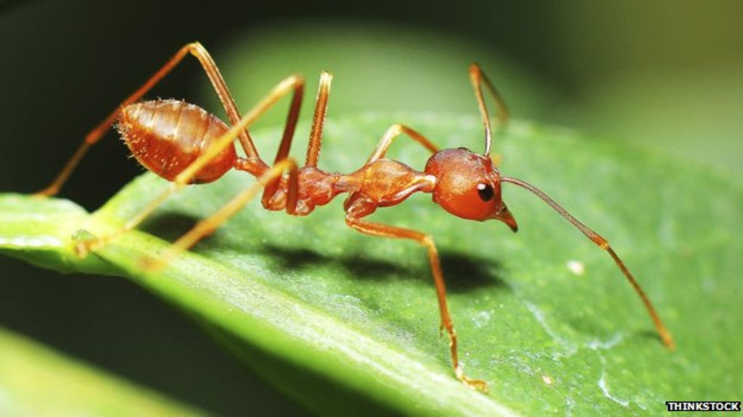

Task 1 - Questions

- The system scientists use to group things divides them first into two groups. What are the two groups?

- With a partner or by yourself, decide whether each of the items meets the requirement to be classified as a living thing (MR N GREWW). Eucalypt tree, water, paper, robot, leather belt, wombat, roast chicken, chair.

- Decide whether each should be classified as a living or non-living.

- Are any of the items listed in your answer dead? Explain your answer

- Use the characteristics of a living thing to describe a bushfire.

- Is a bushfire alive? Explain your answer

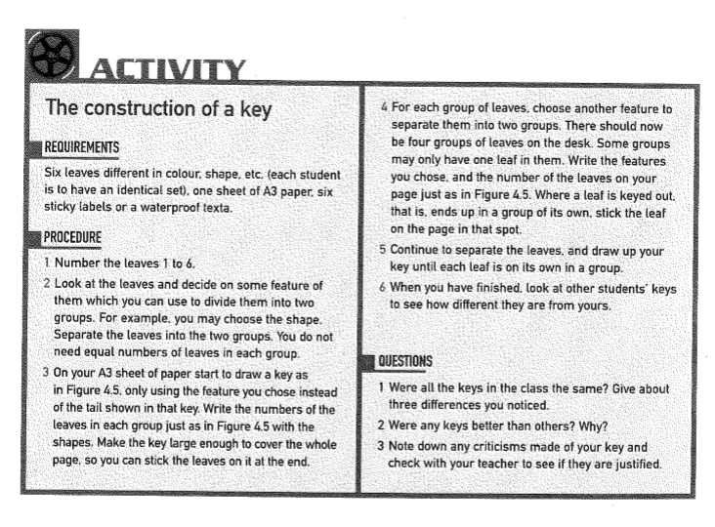
Task 3 - Classification of Plants

Longman (2002) Science Outcomes 1

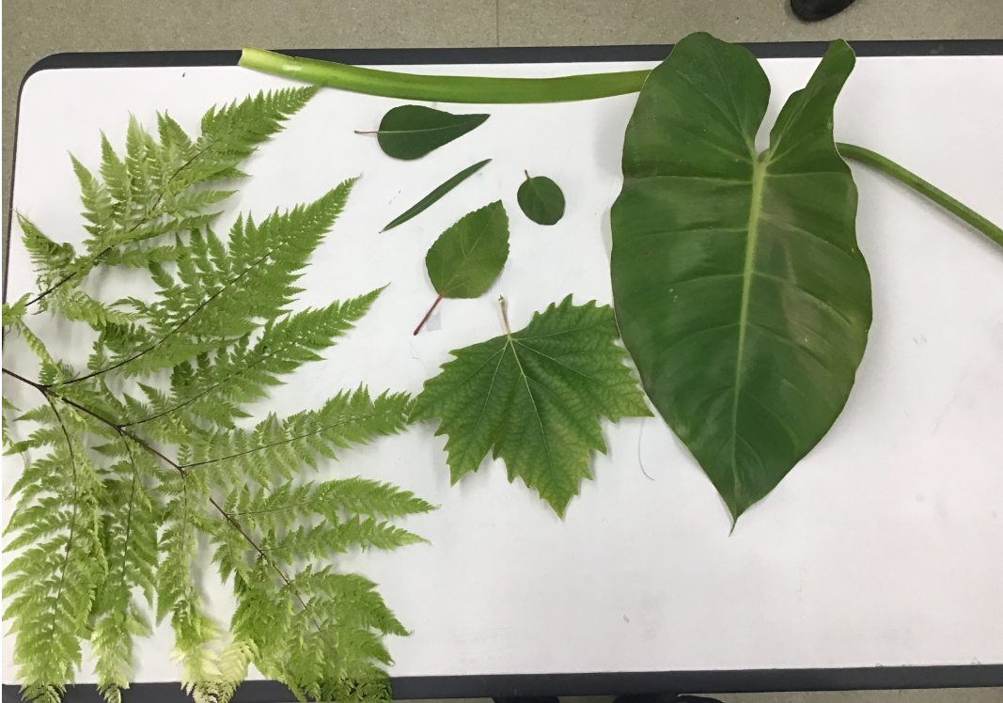

Draw a picture of your key.
After you have made your key. Think about ways that you could classify these leaves all over again in different ways and therefore how your key might be different each time.
For example, you may use single leaf attached vs multiple leaves, or single main vein or multiple direction veins.
When looking for leaf characters features you might consider include:
- Whether leaf has teeth or prickles
- Leaf edge is smooth or wavy
- Colour of leaf stalk
- Size of leaf stalk
- Number of main veins
- Presence of side veins coming off main vein etc
Write some points of interest of how your key could be re-drawn in different ways.

How are plants classified?
Plants are classified based on how they reproduce and whether they have transport systems through the plant. Use the Oxford key below to answer the following questions:
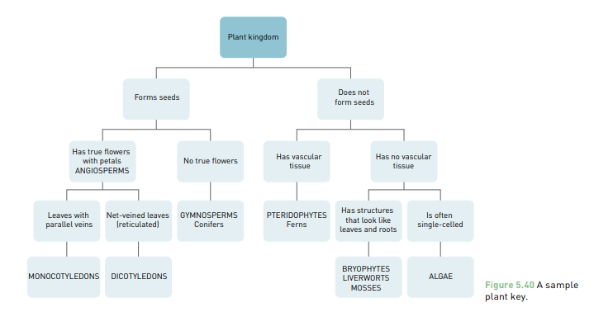Oxford Science 7 p95 (2016)

- Who am I? I have seeds but no flowers?
- Who am I? I do not have seeds nor vascular tissue, but I do have root-like and leaf- like structures?
- How are flowering plants further separated?
- Research the meaning of the names “Angiosperm” and “Gymosperm”.
- Look up the special name given to the leaves of ferns.
- What are the names for the transport tubes of vascular plants that move the food and water around the length of the plant?
- Make a list of some of the differences between monocots and dicots.
- Make up a table of plants you have in your garden and/or home, giving the common name and major group to which it belongs.

Task 3 - Classification Systems ICT

- Write a sentence explaining the difference between living and non-living.

Listed are different people who have created classification systems.
  - Aristotle
  - Andrea Cesalpino
  - John Ray
  - Augustus Quirinus Rivinus
  - Carl Linnaeus
  - Carl Woese
  - Thomas Cavalier-Smith


Search

Research how the different classification systems organise organisms.
Complete the table on the next page.
Name of person who created classification system. | Classification System | How is it organised? | Could this system be used out in the field?

Investigate

What do living species all have in common?

- Explain what MR NGREWW is.

- Research 4 different animals and explain what 8 characteristics they have from MR NEGREWW.

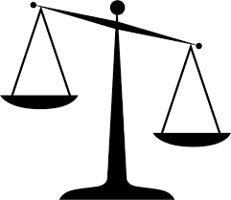
Evaluate

Create a classification key in the space below to classify the 4 animals that you researched.

Cite

Why must I cite my sources?
- I cannot claim the work or ideas of someone else as my own
- Plagiarism is not just when I directly copy words from someone else's work. Plagiarism is also when someone else's work is paraphrased or their ideas are used and claimed as my own
- Referencing has a positive effect and adds credibility to my work
- When I reference correctly, I am demonstrating that (a) I have read widely on the topic and (b) that I am supporting my hypotheses with comments from expert authors and/or reliable sources
- Correct referencing allows the marker/reader to follow-up my references and check the validity of my arguments for themselves.

Surname | Initial | Title of page | Full title of website | Date Written | Internet Address | Date of visit
Brown | J. | ‘Things in Space’ | Astronomy Facts | 1998 | http://www.astronomyfacts.com | 31 July 2019

